1. Specification: 8 Channel (RF8A)
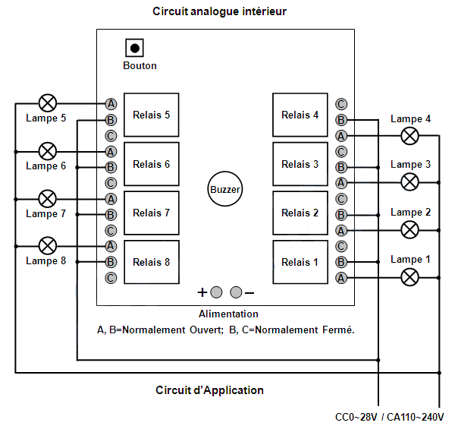

Table 1. Receiver Board
 | Description | Value
1 | Supply Voltage | 12V DC
2 | Static Current | =< 6mA
3 | Frequency | 433 MHz
4 | Sensitivity | >= -105 dB
5 | Relay Spec. | 4A, 120VAC  3A, 24V DC
6 | Operating Temperature | -40 to 80 deg C
7 | Dimension (w, h, d) | 8cm, 10cm, 3cm
8 | Weight (with housing) | 5.8 oz

Table 2. Transmitter (Remote)
 | Description | Value
1 | Battery Voltage | 12V (1 piece)
2 | Dimension (w, h, d) | 5cm, 12.5cm, 2cm
3 | Weight (with battery) | 2.1 oz
4 | Range | 300 m

2. Procedure to Learn and Erase Codes
- Press the “Learn” button on the receiver board, the siren will beep indicating the receiver is ready and waiting to learn from transmitter.
- Press any designated keys to teach and select Output modes. (See table 3)
- In case a remote is lost and a new remote is to be learned, press “Learn” button for ~10sec until the siren beeps 3 times, which indicates previous learned codes have been erased.
Table 3. Output Mode selection.
 | Remote button | Output Mode
A | Press 4 | Momentary
B | Press 2 | Latched
C | Press 8 | Toggle
D | Press 1 | Ch1-Ch6: Toggle  Ch7-Ch8: Momentary

3. Encode/Decode:
On receiver board Auto Learning Decoding Scheme has been programmed into the MCU IC chip, and inside the remote control there is an Encoding IC Chip, 2262. This set of IC Chips can be used to encode your remote signals so if more than one remote system are placed close together, they won't interfere each other. You only need to do little soldering work on the 2262 IC. Pin #1 through Pin #8 bring out the Encode function of your remote transmitter. The receiver board will automatically learn from Transmitter by pressing a learn button. There are {3 to the power 8} = 6561 different combinations for encoding/decoding, isn't it cool?
On the back of the board there should be labels like:
" L" -------- Stands for Low digital state(Close to GND level).
" H" ------- Stands for High digital state(9-12V).
" 1" -------- Indicates this is Pin #1.
" 8" -------- Indicates this is Pin #8.

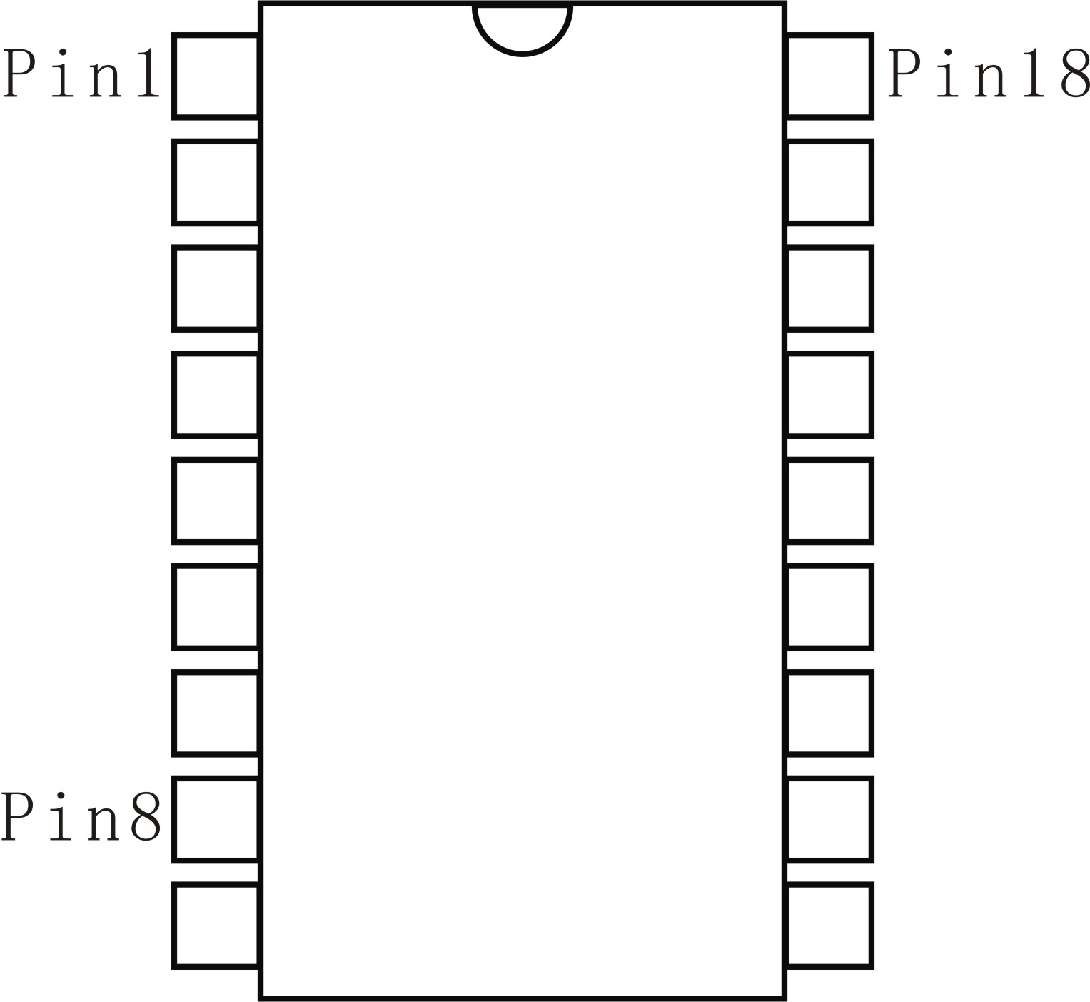
Just in case there aren’t any labels printed on the PCB board, you still can easily figure out the “L” and “H” states yourself: After power is hooked up to the system, use a Voltmeter to measure the contacts on both sides of the column of eight pins. Voltage level on each side should be consistence. If one side is “H”, the other side should be “L”. “H” level voltage can be measured only when signal is transmitting/receiving.
To figure out Pin #1, look at the front side of 2262 IC Chip. Pin #1 is the first pin on the left side of the dent.
You don't have to connect all eight pins to High or Low, even only one pin to H or L will do the encoding/decoding.

*Note: Sometimes remotes are default encoded to be 00000001, pin 8 is shorted to GND.
Encoded IC has following representation:
If the pin is not shorted to anything, its code value is “0”.
If the pin is shorted to “L”, its code value is “1”,
If the pin is shorted to “H”, its code value is a “2”.

