Table of Contents
Table of Contents 1
1. Outlook Description 3
2. Getting Started Guide 4
2.1 Battery Charging 4
2.2 How to use Memory Card 4
2.3 Remove and insert memory card and U disk 5
2.4 Storage Space 5
2.5 Power On and Off 5
2.6 Vibrate 5
2.7 Interface switching 5
2.8 External Network Cable and U Disk 5
2.9 Connecting to the internet 6
2.10 USB connection 6
3. Input operation 7
3.1 Keyboard 7
3.2 Touch Screen 7
4. Desktop 7
4.1 Status Bar 7
4.2 Shortcuts 7
4.3 Current desktop lamp 8
4.4 A quick way to add gadgets 8
5. Web browsing 8
6. Application Management 8
6.1 Install and Uninstall 8
6.2 App Store 10
7. Typical applications introduced 13
7.1 Chat Tool 13
7.2 E-mail 13
7.3 File Browser 13
7.4 My Photo 15
7.5 My Video 16
7.6 Youtube 17
7.7 Magic Album 17
7.8 My Music 18
7.9 Camera 19
8. Tips and Tricks 20
8.1 Some convenient mode of operation 20
8.2 Convenient Set 20
8.3 Battery Tips 22
9. Personalized settings 22
9.1 Wireless controls 22
9.2 Sound and display 22
9.3 Applications 23
9.4 SD cards and devices 23
9.5 Date and Time 24
9.6 Locale and text 24
9.7 About device 25
9.8 Touchpanel calibration 25
10. MID locked 26
11. Troubleshooting 26
11.1 Forced shutdown 26
11.2 Restore default settings 26

1. Outlook Description
Front View:
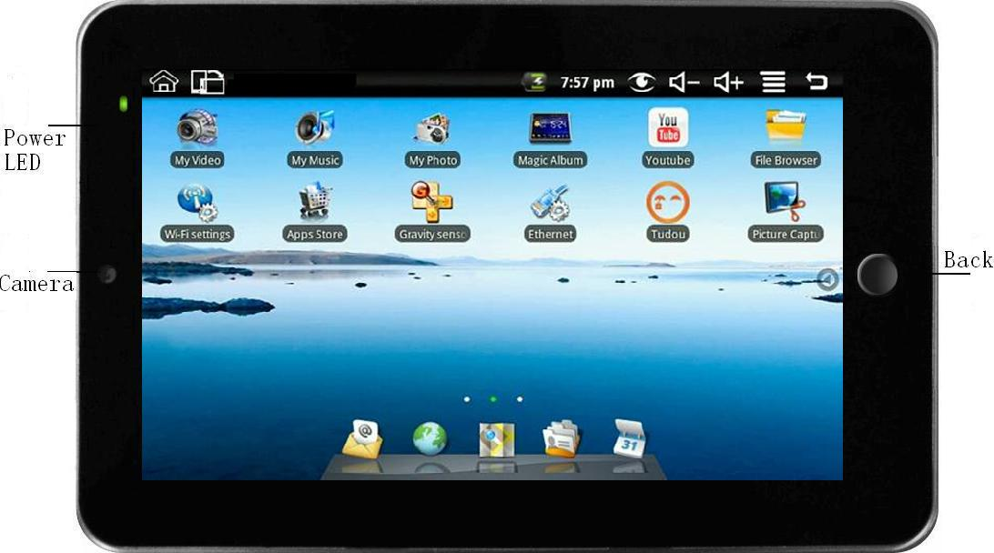
Right side View:
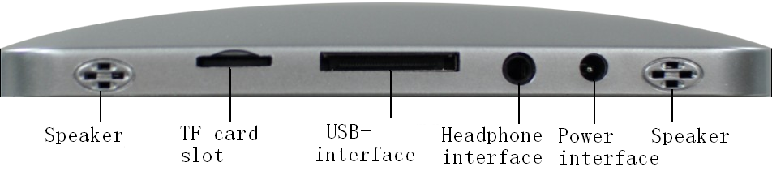
Left side View:
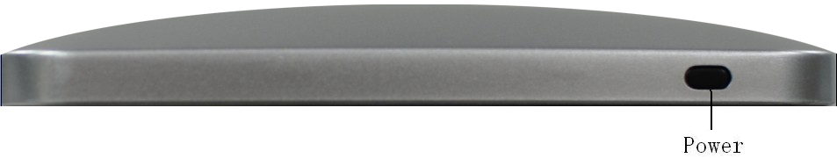
Top View:

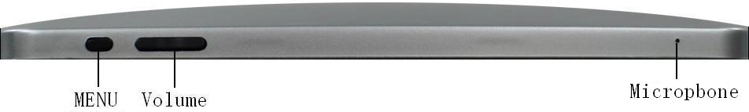

2. Getting Started Guide
Statement：The company has committed to quality, while software update. If the final version of products has any differences from the description of the user guide, please subject to the final product. Thank you!

2.1 Battery Charging
MID has an internal charging battery. We suggest to charge up the battery when the battery power is low.
Power Adapter
One end of the power adapter connecting the socket, and the other end of the power adapter connecting the socket of the device, then the device can be charged.
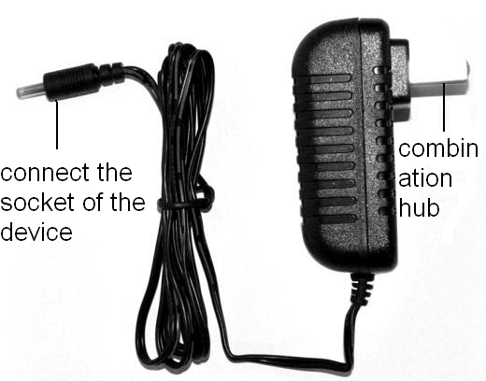
Way to Charging Battery
1. Plug in the power adapter, the battery charge indicator turns red, indicating charging. Plug when the battery is fully charged, the indicator shows green. After unplug the power adapter, the indicator always shows green.
2. During Battery Charging, user can operate MID.
Note:
The charging time will be longer when operating and charging at same time.

2.2 How to use Memory Card
Insert memory card:
Insert memory card to the Card slot. Use finger to put the card into the slot until “click” sound heard.
Upper left corner of the screen will prompt: SD cards are ready.
Browsing files in memory card:
Run "File Browser" program, showing all the files under the root directory. Select "SD card" open to browse the contents of Cary.
Remove memory card:
Close all applications or documents which have been opened from the card.
Press the card lightly. It will be ejected partly. Pull the card out. Upper left corner of the screen will prompt "has been removed SD card".
Note:
1. Insert card to the right position. Otherwise it will damage the card.
2. Once the card has been locked, it can not be formatted or written.
3. Don’t insert and remove the card repeatedly in a short time. It may cause the card damaged.
4. Suggest using major brands of memory card to avoid any incompatibility.

2.3 Remove and insert memory card and U disk
Please don’t remove the memory card and U disk while you are using the files of it. For example, when you are viewing files in my photo, my video or my music, you remove the memory card or U disk directly may cause the memory card and U disk damaged and the device may exit automatically for protection. Remove memory card please refer to“2.2 How to use Memory Card”; remove U disk please close all applications or documents which have been opened from the U disk.

2.4 Storage Space
The device has three storage spaces: internal device storage, U disk and memory card. The internal device storage named “LocalDisk”; the memory card named “sdcard”; and the external U disk named “udisk”. The user can use space in the localdisk is probably 1G. The U disk and memory card is on its specific capacity, the maximum support to 32G memory card.

2.5 Power On and Off
1、Power On: When power adaptor is plugged, User can press Power button to enter the Window Platform.
2、Power Off: User can long press (2 seconds) power button, then system will pop up equipment selection dialog box. Select shutdown, System will then pop off the confirmation dialog box, select OK you can shut down. User can long press (8 seconds) power button to shut down the machine.
3、Hibernate: User can long press (2 seconds) power button, then system will pop up equipment selection dialog box. Select dormancy, the system will into hibernation. Then press the power button to boot.
4、Airplane mode: User can long press (2 seconds) power button, then system will pop up equipment selection dialog box. Select airplane mode, the system will into airplane mode.

2.6 Vibrate
Open vibrate:
Click volume icon on the status bar to adjust the volume to zero to put it on vibrate mode.
Close vibrate:
Make the volume is not zero, and then the vibrate mode closed.

2.7 Interface switching
System interface can switch the screen automatically according to the direction of the device. Screen time on a two second, the conversion process will become dimmer, the screen switch to normal after finishing.

2.8 External Network Cable and U Disk
Transfer Box:
If you want to connect Ethernet or USB, you need to connect a transfer box first.
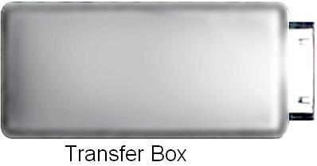
Make the interface of the adapter connect to the USB interface of the device. There are two USB interface and an Ethernet interface on the adapter. You can connect external network cable and U disk.

External network cable:
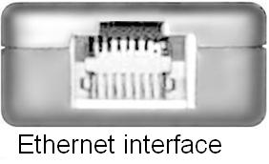
Insert the network cable into the Ethernet interface like the left picture after the adapter is connected to the device. You can get the IP address automatically and also can select to set the IP address by hand.

External U disk:
Insert the U disk into the USB interface like the left picture after the adapter is connected to the device. You can copy files among SD card, U disk and internal device storage after the U disk is connected to the device. Copy method you can refer to“7.3 File Browser”.

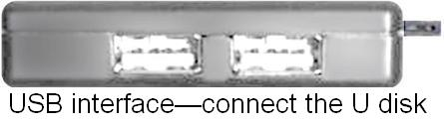

2.9 Connecting to the internet
Connecting to the internet by Ethernet：
Make the transfer box connected to the USB switch interface of the devices, and then plug the network cable into the Ethernet port of the transfer box, in the upper right corner of the screen appears "ETH".MID automatically obtain IP address via DHCP to connect the network. If you want to set IP, please go to the Ethernet, and refer to “8.Tips and Tricks”.
Connecting to the internet by Wi-Fi：
1. Click MENU key to pop-up the menu, and then select "Settings";
2. Select "Wireless Control" in the settings menu;
3. Select the box behind the open Wi-Fi;
4. Open Wi-Fi Settings;
5. All the AP in the vicinity will be listed, click to select the name you want to connect to AP;
6. If the AP before the connection is successful, the AP information will be saved in the pop-up window, select "Connect" starts to connect, choose "forget" to remove AP information;
7. If the AP is not encrypted, in the pop-up window, select "Connect" Start Connection;
8. If the AP is encrypted, enter the password in the pop-up window, and click "Connect" Start Connection;
9. When internet connections are successful, the wireless connection icon in the status bar appears.

2.10 USB connection
Device can connect to the computer, and then can copy files each other. If the devices with memory card, it will display two disks in the computer after connecting the computer. One is memory card, and the other is the internal device storage.
Connect:
1. Make the transfer box connected to the USB switch interface of the devices, and then plug the USB cable into the USB interface of the transfer box and connect USB interface of the computer;
2. Tap MENU→Notification→USB connected;
3. Tap "Mount" after the pop-up boxes;
4. Now the device has been connected with the computer, then going to My Computer under removable disk devices can copy files among the internal device storage, SD card and the computers.
Turn off:
Method 1.Tap MENU→Notification→Turn off USB storage, and then tap “Turn off” you can disconnect the device and the computer after the pop-up boxes.
Method 2.Click to move the letter icon on the computer, and select the security you can disconnect the device connected to the computer.
You can unplug the USB cable after disconnecting.

3. Input operation

3.1 Keyboard
When you need to enter text and numbers using the program or file, the touch screen keyboard will appear automatically.
Note: This machine supports an external USB keyboard, but when using an external USB keyboard, some keys may not work properly.

3.2 Touch Screen
Touch Screen senses the finger trajectory and can do the following:
Note: Please do not place objects on the touch screen surface, it may be scratched or crushed.
Click: Select an icon to click, and then you can select the icon or option;
Long press: Select a single icon and do long press and then you can drag it to the desktop display.
Drag and Drop: Drag the desktop you can switch between the three interfaces.
In the process of using the screen process you can use a pencil instead.

4. Desktop

4.1 Status Bar
The top screen for the status bar, display SD card, network, battery status, time and volume change, etc…
 Battery status icon Time display  Volume reduction icon
 Volume increase icon  Shortcut menu icon  Back icon
 Desktop icon Wi-Fi status icon  Picture capture icon
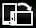 Rotating screen icon

4.2 Shortcuts
On the desktop, press the MENU, bottom of the screen will pop up the shortcut menu. Menu items include: Add, wallpaper, search, notification, settings and hide. It shows like the following picture:
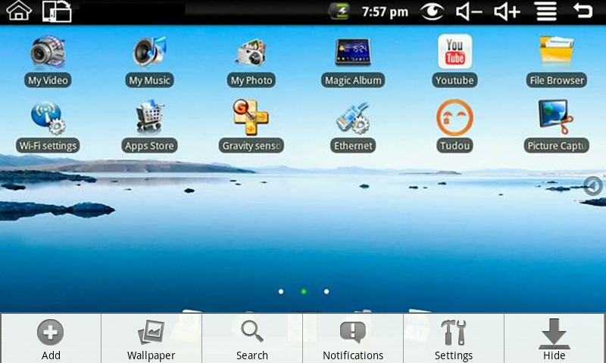

4.3 Current desktop lamp
The device Desktop has three dots light, that is, a total of three interfaces, the current interface will display the green dot. If the indicator shows like, then the current in the second interface.

4.4 A quick way to add gadgets
Shortcuts
To add a shortcut to the main screen, press MENU → Add → Shortcut. Select the shortcut and then it can be added to the main screen. After adding you can click the shortcut icon on the main screen to do the corresponding shortcuts.
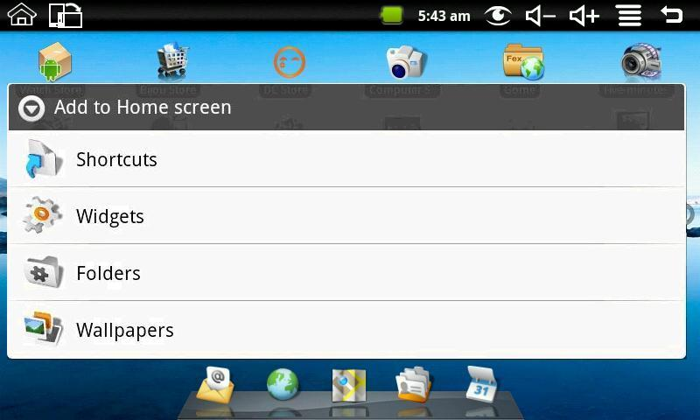

5. Web browsing
Users can connect to the Internet through a browser.
Click the browser icon on the Desktop, and then you can open the Web browser.
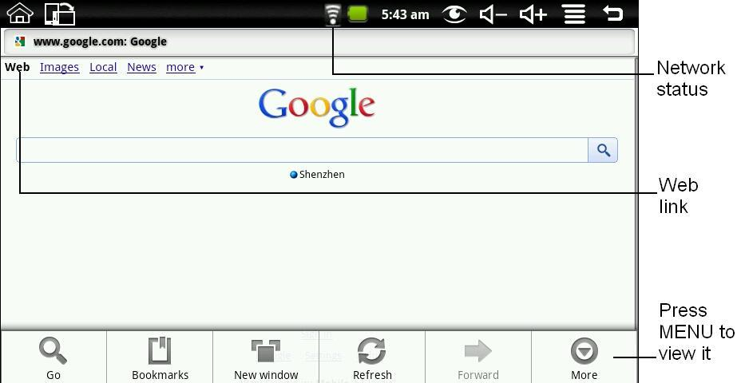

6. Application Management

6.1 Install and Uninstall
Install
To install third-party software, please enter file browser first. And then find the APK file from the memory card, like the following picture:
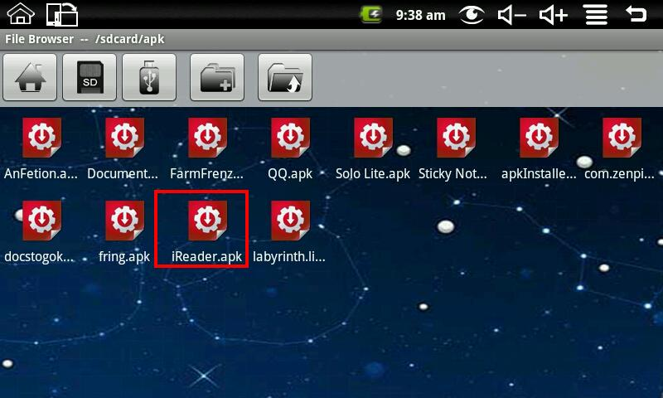
Click iReader.apk like the above picture to pop up the install interface:
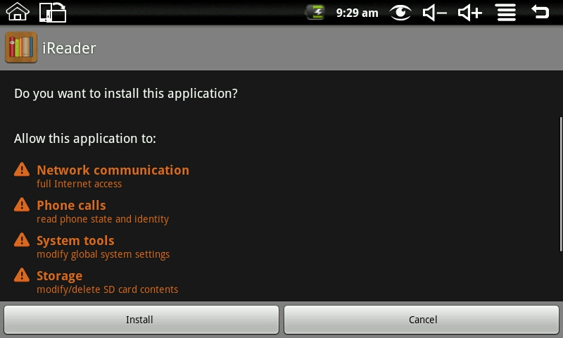
Click install button, and then the device will begin to install iReader. It shows like the following picture after installing:
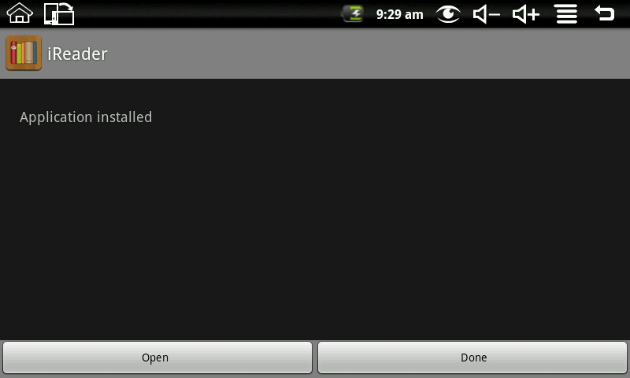
Now the application is installed. Click open can open iReader directly and click done to back to the file browser.
Uninstall
To uninstall third-party software installed, press MENU → Settings → Application → management application. Like the following picture:
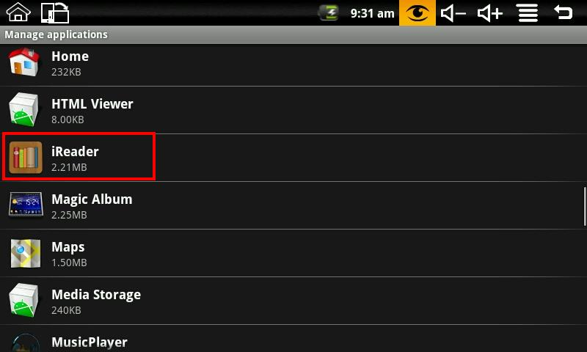
Click the application you want to uninstall, like iReader on the above picture. It will pop up the uninstall interface like the following picture:
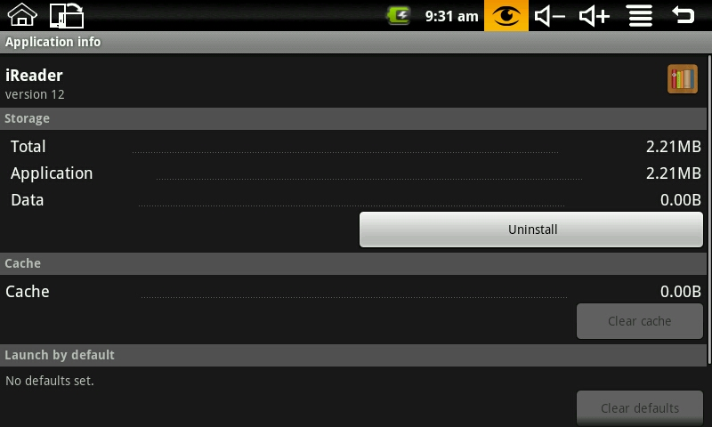
Click Uninstall to enter the confirmation uninstall interface:
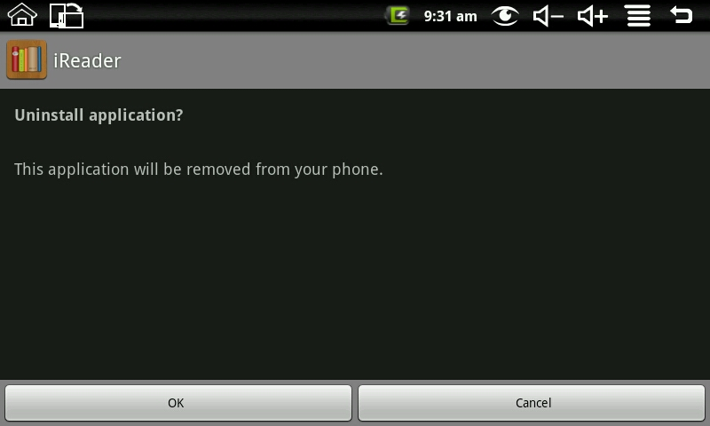
Click OK to uninstall the application. Uninstall finished interface shows like the following picture:
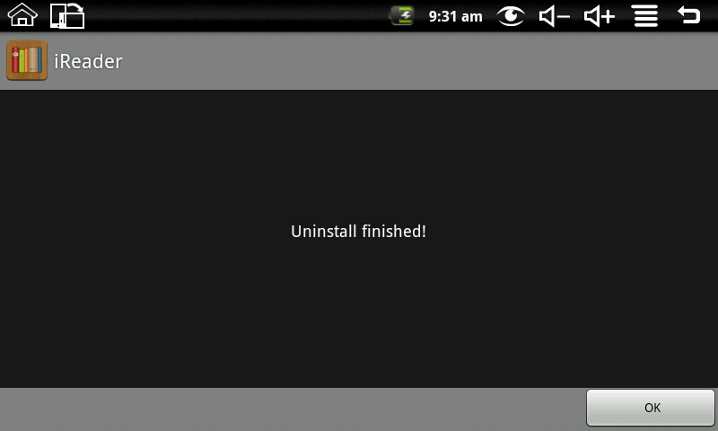
By now, iReader is uninstalled from the device.

6.2 App Store
Click App Store iconto enter the following interface:
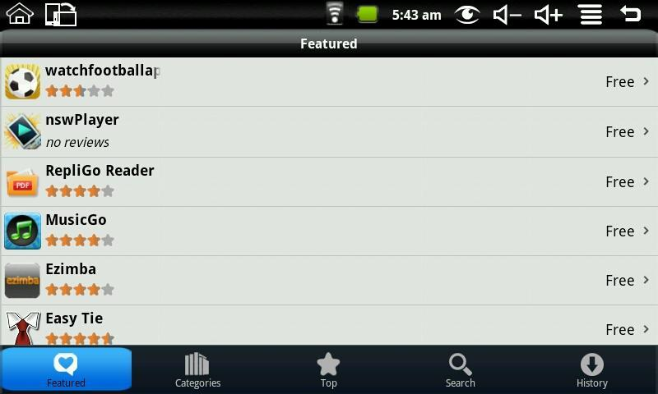
You can click on the Featured, Categories, Top, Search and History to see the relevant information.
Press MENU to pop-up shortcut menu as follows:
Click login, it shows like:
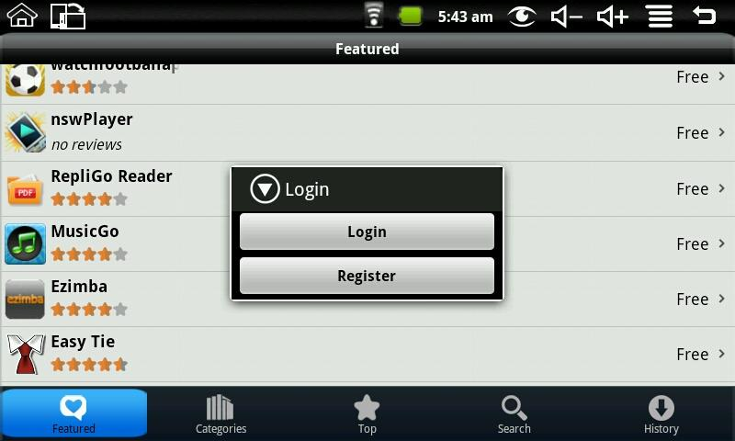
If no account, select register, and you need to enter E-mail, Account Name and password. The registration interface as follows:
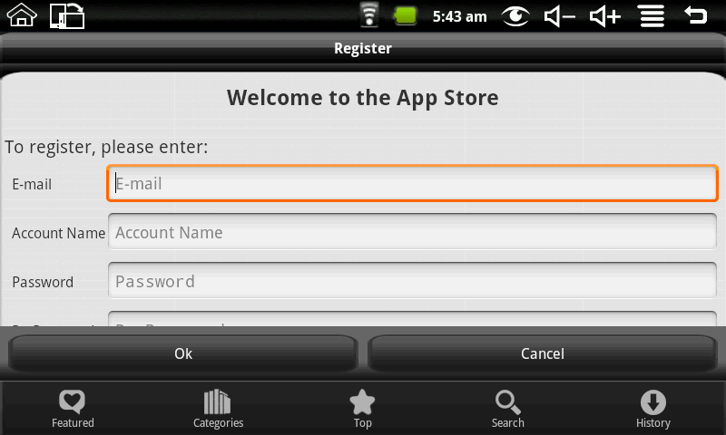
If there is account, select the login, and enter the account number and password to login; it shows like:
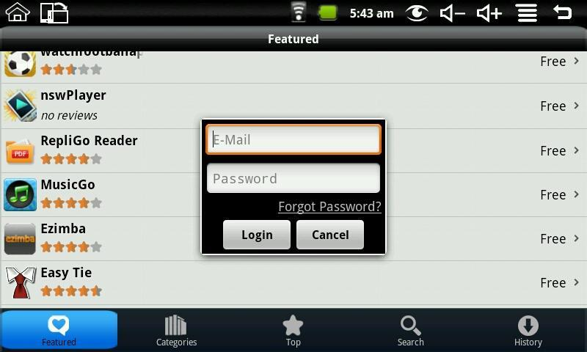
After login you can enter the following interface:
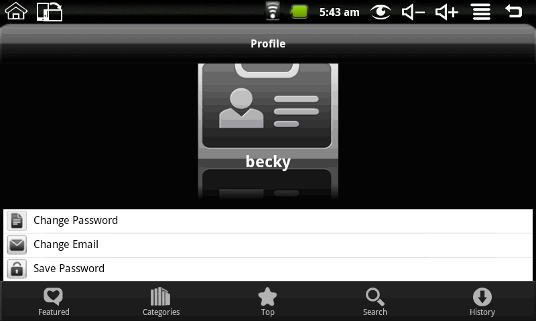
You can choose to change password, change Email and save password. If you want to download the application software, you only need to click the icon on the following picture:
For example: click featured to enter the next interface:
Click the application you want to download to enter the details interface. Click download, it will pop up enter account password. Enter your account password after the start the download. The next picture is an example for Chinese Chess:
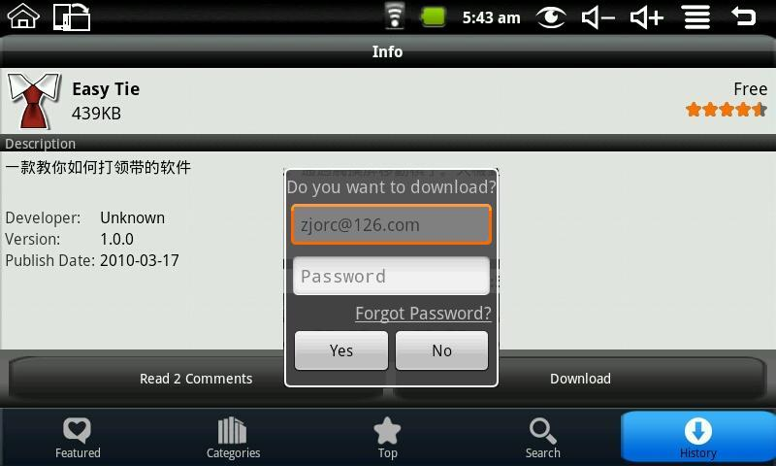
After the download is complete it will pop up installation tips automatically, click install the application can be installed on the device.
After installation is complete you can click history to manage the installed applications. As the following figure on history for the application:
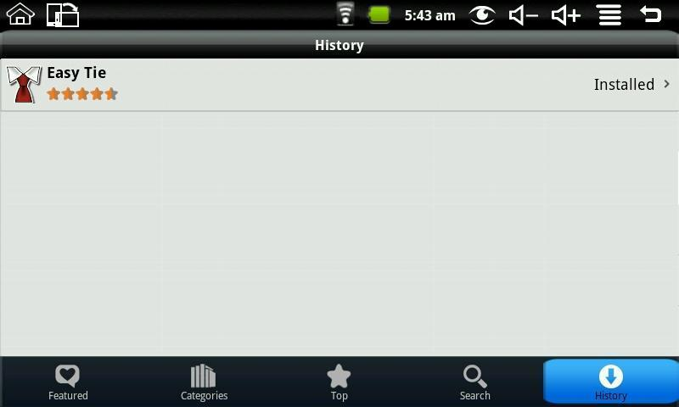
The action could do with the application are: comment, open and uninstall.
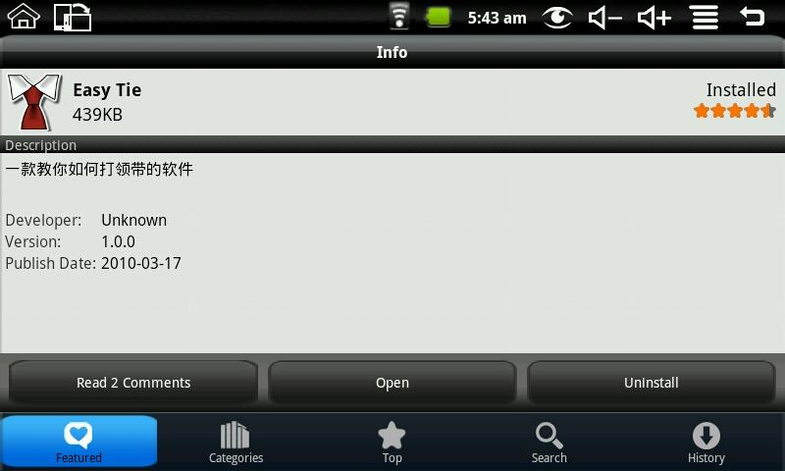
Click comment you can comment with the application; click open you can open the application; click uninstall you can uninstall the application from the device.

7. Typical applications introduced

7.1 Chat Tool
You can download the chat tools such as FRING, QQ and MSN.

7.2 E-mail
Click the E-mail iconcan enter the e-mail, and then you can proceed as follows:
1. Set e-mail account;
2. Open a new e-mail;
3. Send and receive e-mail.
Note: Press MENU to pop-up shortcut menu.

7.3 File Browser
Click the file browser icon 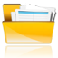to enter file browser interface:
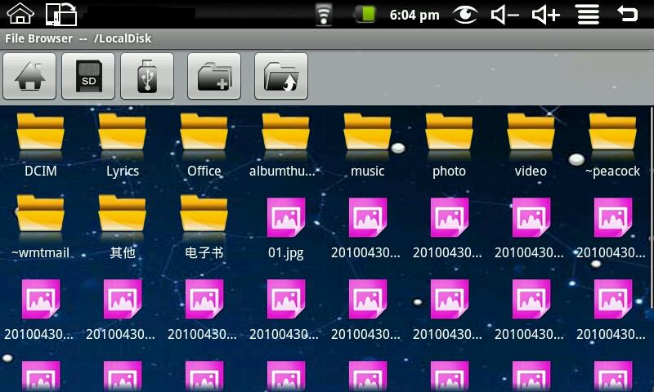
In the file browser, it can back to the previous, create new folder, switch to U disk “udisk” 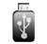, switch to memory card “sdcard”and switch to internal device storage “LocalDisk” .
Copy files:
In the file browser, the internal device storage named “LocalDisk”; the memory card named “sdcard”; and the external U disk named “udisk”. If you want to copy files among memory card, U disk and internal device storage, please refer to the following actions:
Example: copy files from external U disk to the internal device storage.
- Enter the file browser and click the memory card iconto enter the sdcard folder;
- Select the file you want to copy and press the icon for 2 seconds, then it will pop the following list:
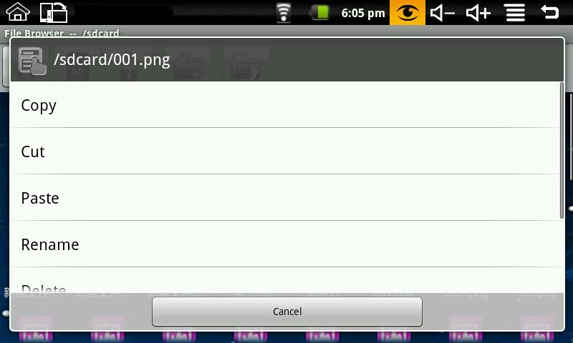
- Click copy;
- Click the internal device storage icon to enter the LocalDisk folder;
- Long press the blank to pop the following list:
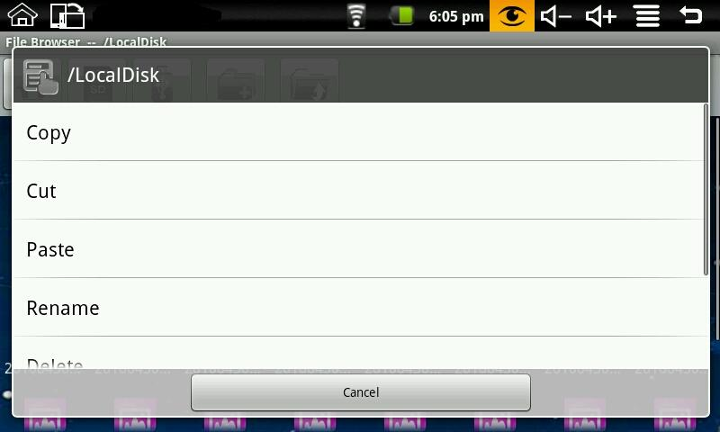
- Click paste to paste this file into the current directory.
Delete files:
Select the file you want to delete and press the icon for 2 seconds, then it will pop an operating list. Select delete to pop the following confirmation delete dialog:
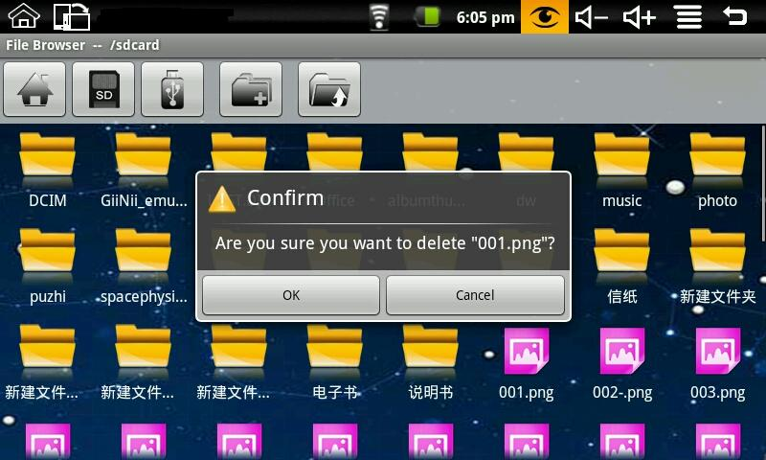
Click OK to delete the file.

7.4 My Photo
Click My Photo icon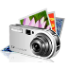 to browse pictures:
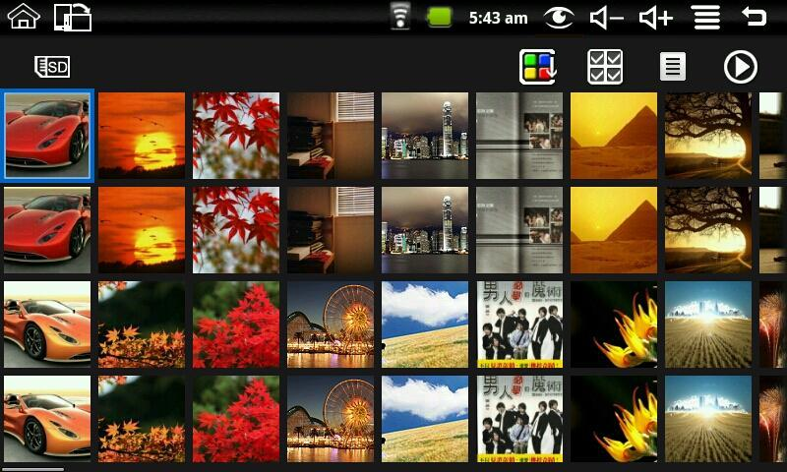
Click on any picture to enter slideshow mode. The mode can be full-screen pictures, rotate pictures, select the picture effect, change the picture arrangement, operation and slide play set.
Click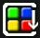to switchable arrangement of pictures;
Clickcan do delete and properties;
Clickcan set the picture slide player mode. There is general play, miss, dynamic, romantic, quiet and clean.
Filter folder:
Press MENU button or click MENU icon in My Photo will pop up the following shortcut menu:
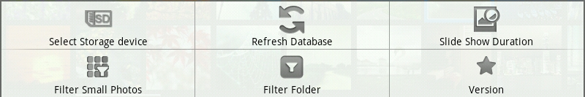
Click filter folder and then you can filter all the folders with photos, like the following picture:
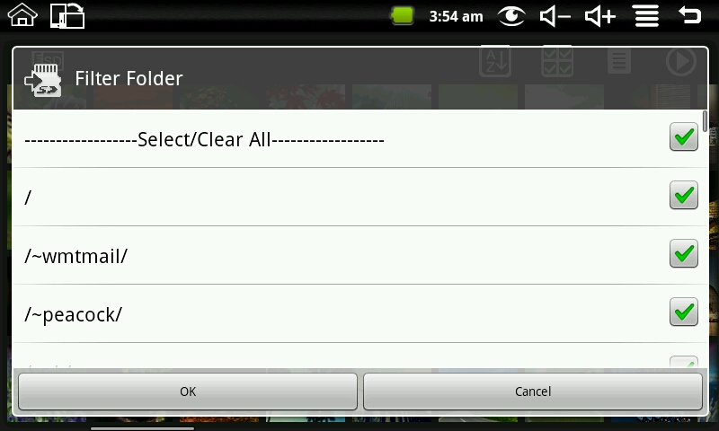
If “Select/Clear All” is selected, all the photos will be displayed; and if “Select/Clear All” is not selected, there will no photo be displayed.
If you don’t select one folder single with “Select/Clear All” is selected, the photos in this folder will not be displayed; and if you select one folder single with “Select/Clear All” is not selected, there will only displayed the photos in this folder.
The picture format can be supported: JPEG, BMP and PNG.

7.5 My Video
Click My Video icon to get in the list of the video
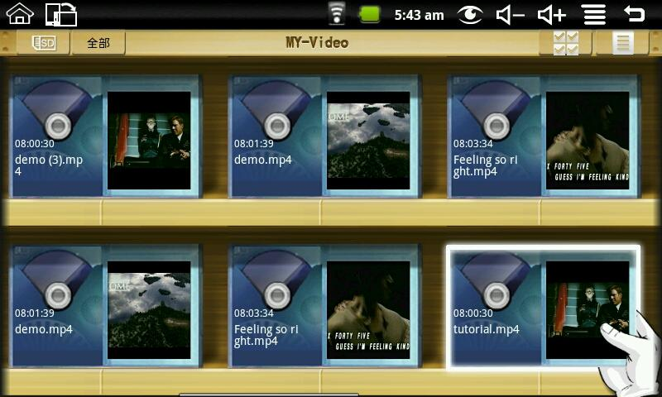
Click one of the video can be broadcast, can adjust the volume during playback, fast forward, rewind, pause, adjusting brightness and return.
Filter folder:
Press MENU button or click MENU icon in My Video will pop up the following shortcut menu:
Click filter folder and then you can filter all the folders with videos, like the following picture:
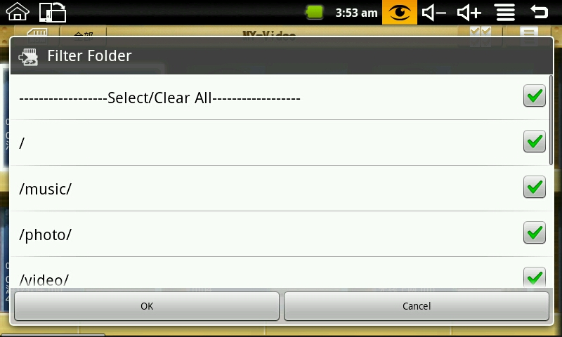
If “Select/Clear All” is selected, all the videos will be displayed; and if “Select/Clear All” is not selected, there will no video be displayed.
If you don’t select one folder single with “Select/Clear All” is selected, the videos in this folder will not be displayed; and if you select one folder single with “Select/Clear All” is not selected, there will only displayed the videos in this folder.
The video format can be supported: H263, MPEG4 and 3GP. It supports QVGA (500kbps).

7.6 Youtube
Click Youtube video icon to view all videos:
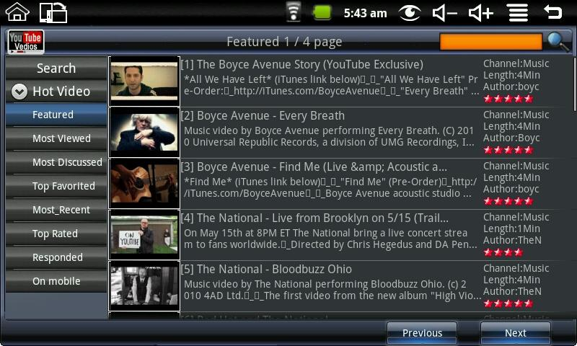
Search: You can input a search.
Hot Video: Including by featured, most viewed, most discussed, top favorited, most_recent, top rated, responded and on mobile.
Click the video on the list can be directly played.

7.7 Magic Album
Click Magic album icon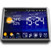 into the magic album interface. It can display weather, date and time, My Photo, my music, brightness adjustment and alarm clock.
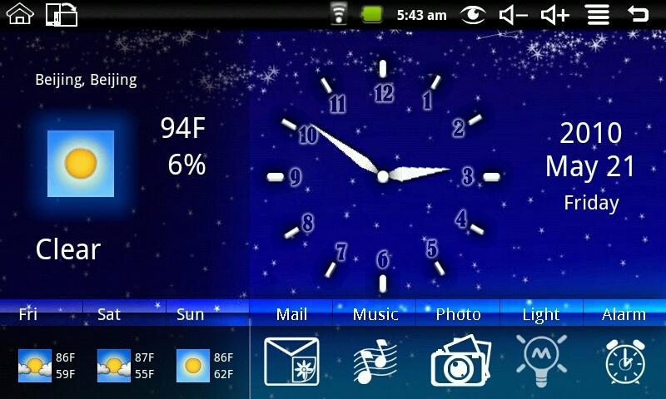
Click the mail icon to enter my photo to view all of the pictures in the Email.
Press MENU to pop up the shortcut menu, including flushing the weather, setting and on.
Setting: Can do the city, date and time, the background image, open the screensaver settings.
Photo Mail:
When the system out a new mail instructions, enter the magic album, the Mail icon will become green. Click the mail icon into my photo to check the picture of e-mail.

7.8 My Music
Click My Music icon  to enter it, and you can click to play songs.
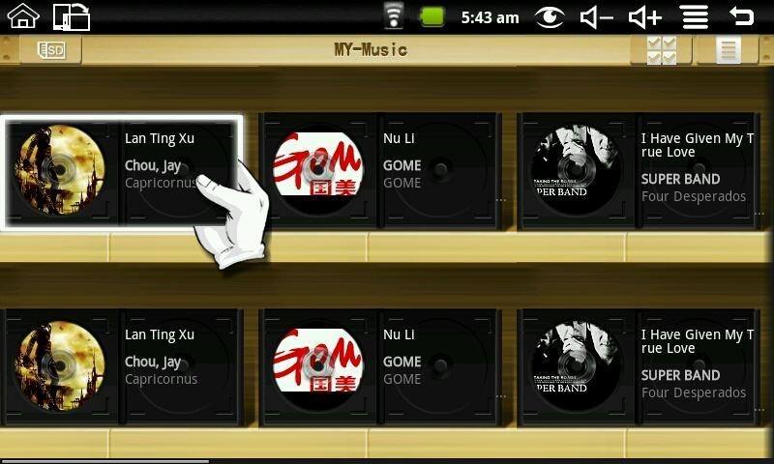
Filter folder:
Press MENU button or click MENU icon in My Music will pop up the following shortcut menu:
Click filter folder and then you can filter all the folders with music, like the following picture:
If “Select/Clear All” is selected, all the music will be displayed; and if “Select/Clear All” is not selected, there will no music be displayed.
If you don’t select one folder single with “Select/Clear All” is selected, the music in this folder will not be displayed; and if you select one folder single with “Select/Clear All” is not selected, there will only displayed the music in this folder.
Play music:
Click the volume increase and the volume reduction icon of the status bar can adjust the volume.
In the process of play music you can drag CD discs through your fingers to achieve quickly turned and hit back ：
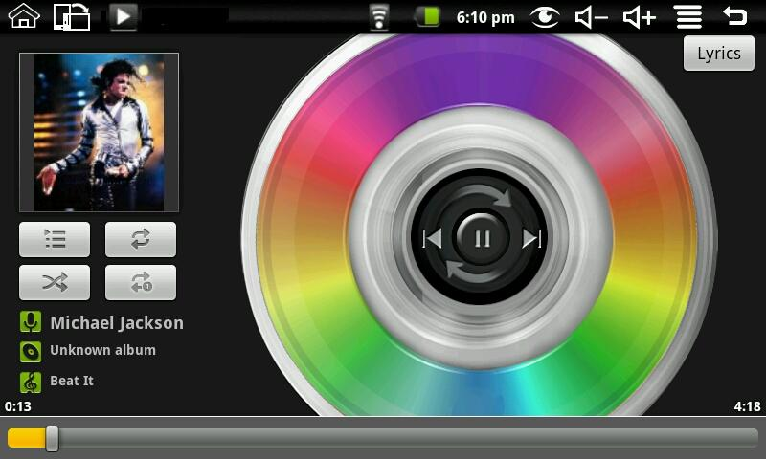
Click the lyrics button on the top right corner and then the discs icon will become to lyrics table. It shows like the following picture:
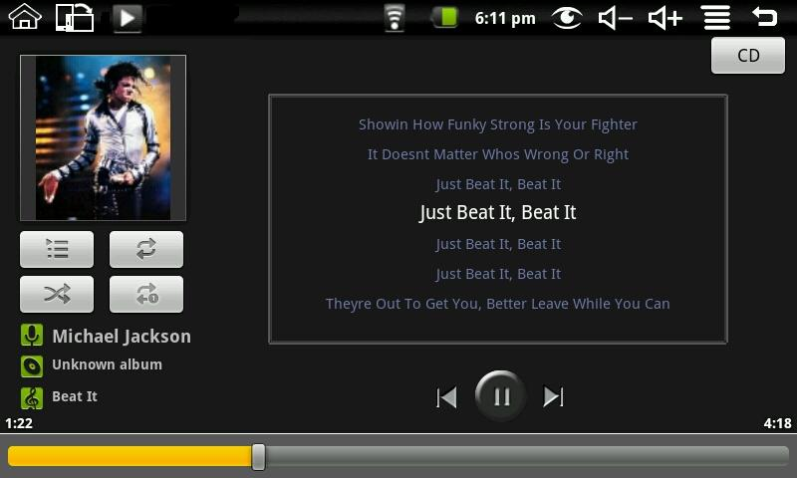
If there are no relevant lyrics, it will display like the following picture after clicking the lyrics button:
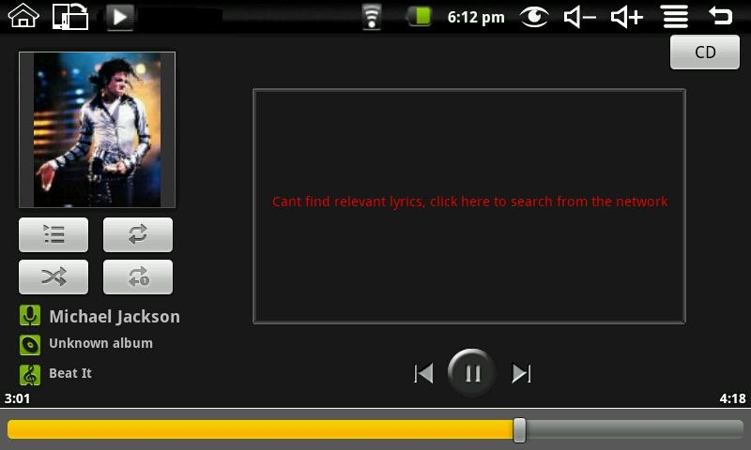
Click the lyrics box on the above picture, and then it will appear a search box. Input the singer’s name in the artist, input the song’s name in the songs, and select best match auto download. Then press OK to download the lyrics from the network.
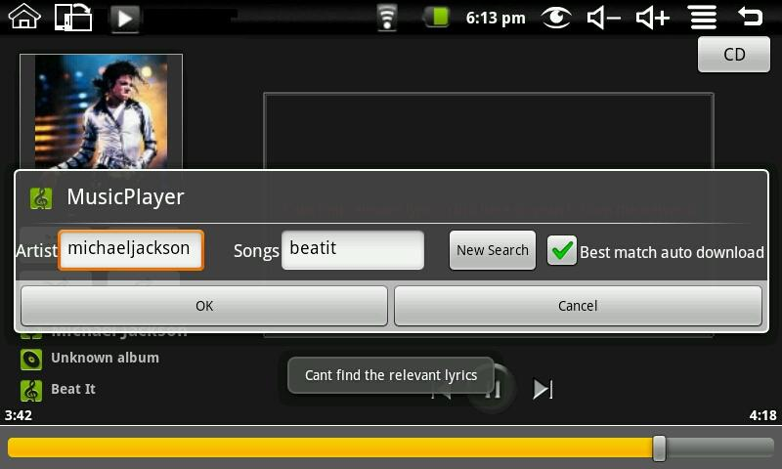
The video format can be supported: MP3, WAV, AAC and AMB.

7.9 Camera
Click Camera iconto get in, and you can take photos or record video. Press MENU to pop-up shortcut menu:
You can tap on the shortcut menu "Switch to the camera" or tap the icon to switch to camera mode.
Click the Photo into My Photo to view all photos taken with the camera.
Click on Settings to enter the camera settings interface, you can do camera-related settings. Include: Store location in pictures, Select video quality, Select video duration, Select picture size, Select picture quality and Select focus mode.
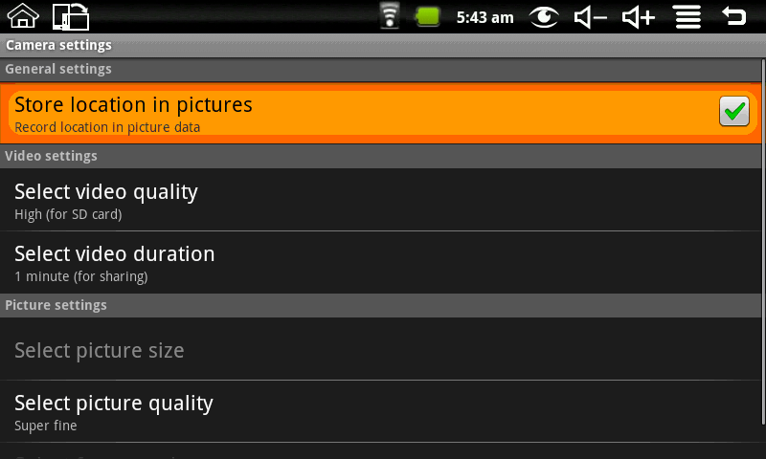

8. Tips and Tricks

8.1 Some convenient mode of operation
Home screen——Click
Adjusting the volume——Click /

8.2 Convenient Set
Wi-Fi settings:
Click Wi-Fi settings iconto enter the Wi-Fi settings. The interface to the following figure shows：
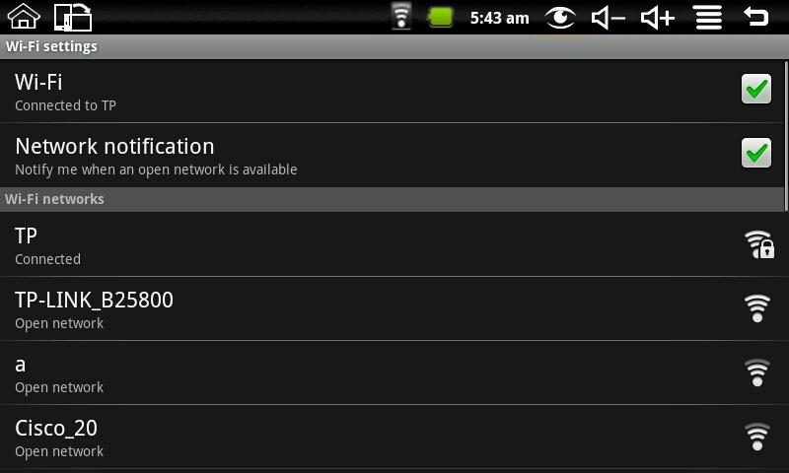
Ethernet:
Click Ethernet icon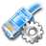to enter the Ethernet. You can set IP by hand. The interface to the following figure shows：
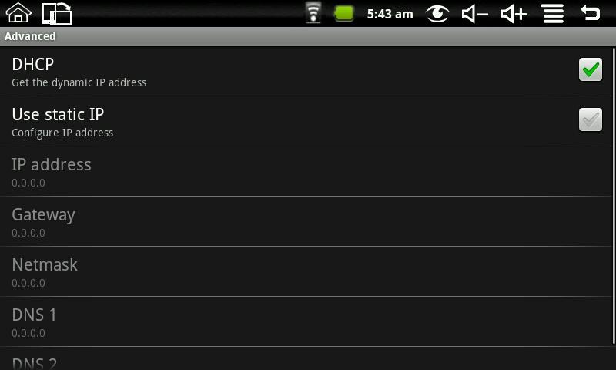
Gravity sensor setting:
Click gravity sensor setting iconto enter, and then you can make the gravity sensor setting to be normal mode and game mode.
Picture Capture:
Click picture capture icon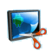 to do picture setting. You can set select delay time to capture the screen and select the default storage device.
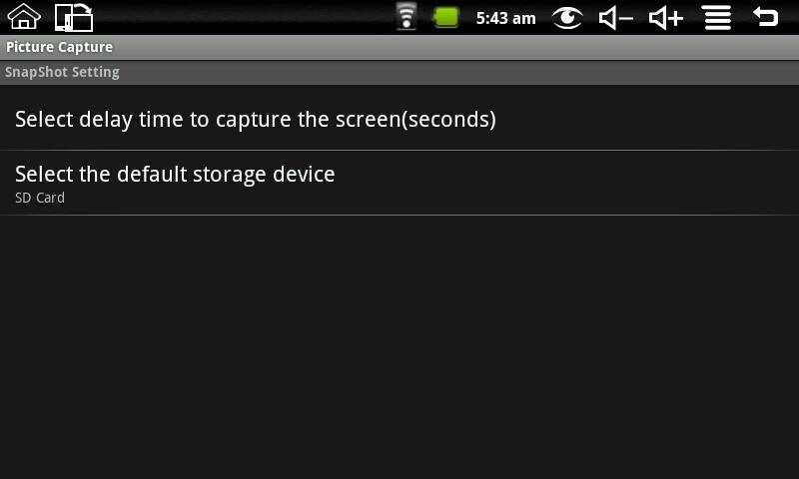
Picture storage: The pictures captured are saved in the Internal Flash (ROM) default, and you can select the default storage device to be SD card and USB storage.
Delay capture: if you need to delay capture, please click picture capture iconon the desktop to enter first, and then select “Select delay time to capture the screen (seconds)” to enter the next interface like the following picture:
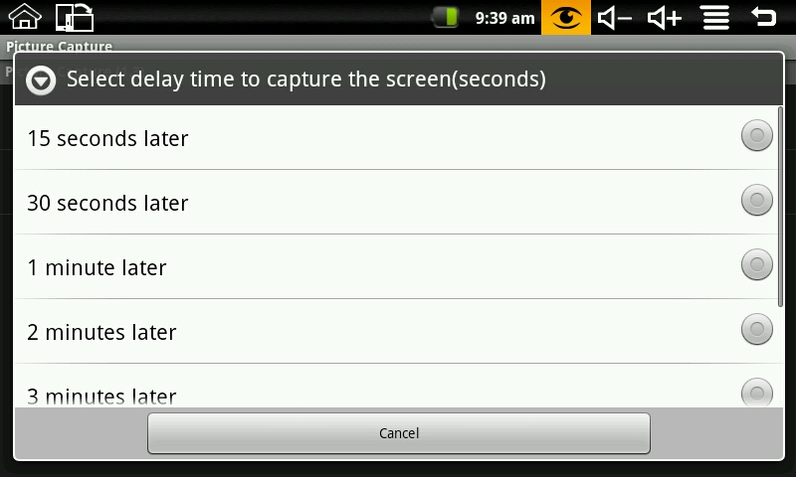
Select the delay time and then the device begin timing, after the timer it will capture the interface. The method applies to the full screen interface don’t have the status bar to the desktop.
Immediate capture: click the picture capture icon on the status bar to capture the interface. The method applies to the interface have the status bar to the desktop.

8.3 Battery Tips
As the device has a large screen, it will consume a lot of power. To extend battery life, you can reduce the frequency of use of the following features:
1. Recording or watching videos, listening to music or take photographs;
2. Display brightness: Please press MENU → Settings → Sound and Display (Display Settings) → brightness (reduce the brightness);
3. Web Search: Please press MENU → Settings → Wireless controls → Wi-Fi settings → Network notification;
4. Wi-Fi use: Please press MENU → Settings → wireless controls → Wi-Fi (turn off Wi-Fi).

9. Personalized settings
Click the settings on the shortcut menu can be personalized settings.

9.1 Wireless controls
Manage Wi-Fi and airplane mode
Wi-Fi
If you want to open and close the Wi-Fi, please press MENU → Settings → wireless controls→ Wi-Fi.
Wi-Fi Settings
If you want to set up and manage the wireless access point, please press MENU→ Settings → wireless controls → Wi-Fi settings.
Airplane mode
If you want to set airplane mode and disable all wireless connections, please press MENU→ Settings → wireless controls → airplane mode.

9.2 Sound and display
Set t ringtones, notification, and screen brightness.
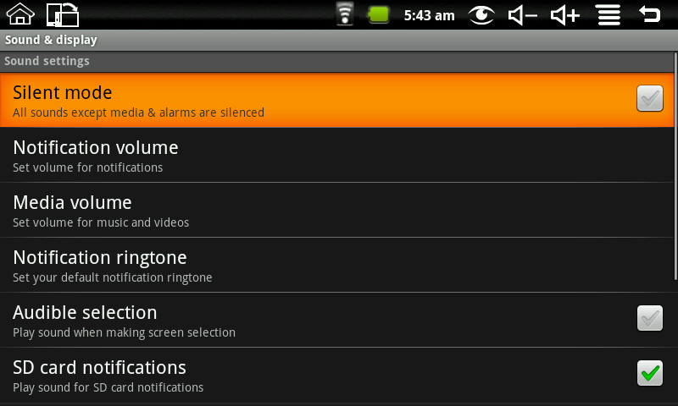
Silent mode
To make the addition to the media and the alarm clock, all located to mute the sound, press MENU → Settings → Sound and display (sound settings) → silent mode.
Notification volume
To set the volume of inform, press MENU → Settings → Sound and display (sound settings) → notice the volume.
Media volume
To set the volume of music and video, press MENU → Settings → Sound and display (sound settings) → media volume.
Notification ringtone
To set the ring of the default notification, press MENU → Settings → Sound and display (sound settings) → notification tone.
Audible selection
To make sound choices for the screen, press MENU → Settings → Sound and display (sound settings) → operation sound choice.
SD card notifications
To make the SD card notification sound, press MENU → Settings → Sound and display (sound settings) → SD card notification.
Orientation
Press MENU →Settings → sound and display settings (display settings) → orientation, you can switch orientation automatically when rotating. If you choose “switch orientation automatically when rotating”, the interface will switch automatically when the device had rotated. If you don’t choose “switch orientation automatically when rotating”, there will display a rotating screen icon on the status, and the interface will switch following the device only if you click the rotating screen icon.
Animation
To open and close the window to display animation, press MENU → Settings → Sound and Display (Display Settings) → animation.
Brightness
To adjust the brightness of the screen, press MENU →Settings → sound and display settings (display settings) → brightness.
Screen timeout
To adjust the screen automatically turns off before the delay, press MENU → Settings → Sound and display (display settings) → standby screen.

9.3 Applications
Unknown Source
After checking it is allowed to install application which is not provided by the electronic market.
Manage applications
To manage and remove the installed applications, press MENU → Settings → Application → management application.
Development
To set options for application development, please press MENU → Settings → Application → development.

9.4 SD cards and devices
Unmount SD card, view available storage
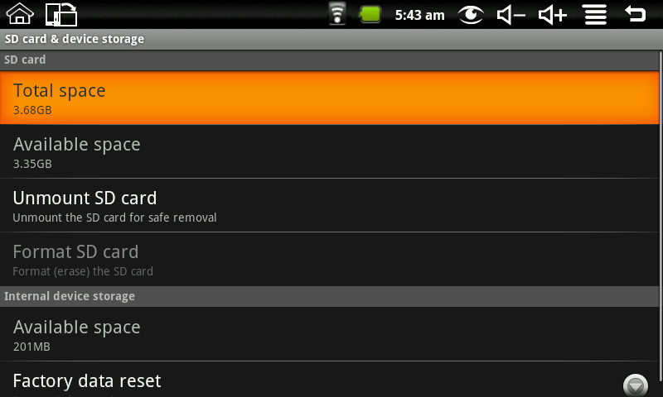
Total Space
Press the MENU → Settings → SD card and device memory (SD card) → total storage capacity, you can view the total amount of localdisk storage and SD card .
Available space
Press the MENU → Settings → SD card and device memory (SD card) → total storage capacity, you can view the available space of localdisk storage ,SD card and internal device storage.
Unmount SD Card
To remove the SD card in a safe remove, press the MENU → Settings → SD card and device memory (SD card) → remove the SD card.
Format SD Card
To format the (clear) SD card, press the MENU → Settings → SD card and device memory (SD card) → formatted SD card.
Factory data reset
To restore factory settings, press MENU → Settings → SD card and device memory (internal storage device) → factory data reset.

9.5 Date and Time
To set the date, time, time zone, time and format of the system, press MENU → Settings → Date and Time.
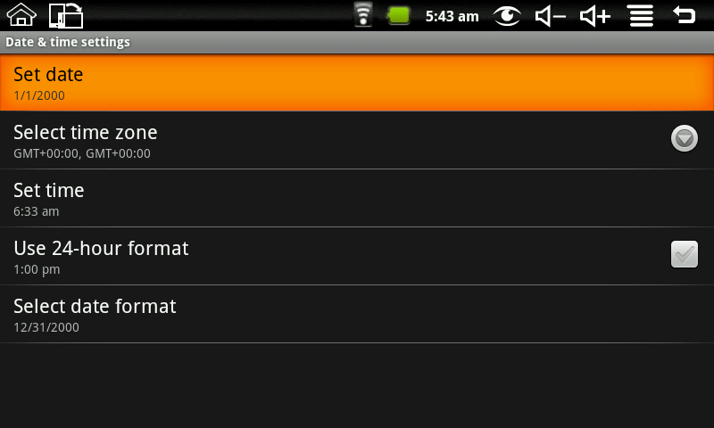

9.6 Locale and text
Set local (language and region), text input and auto-correction options
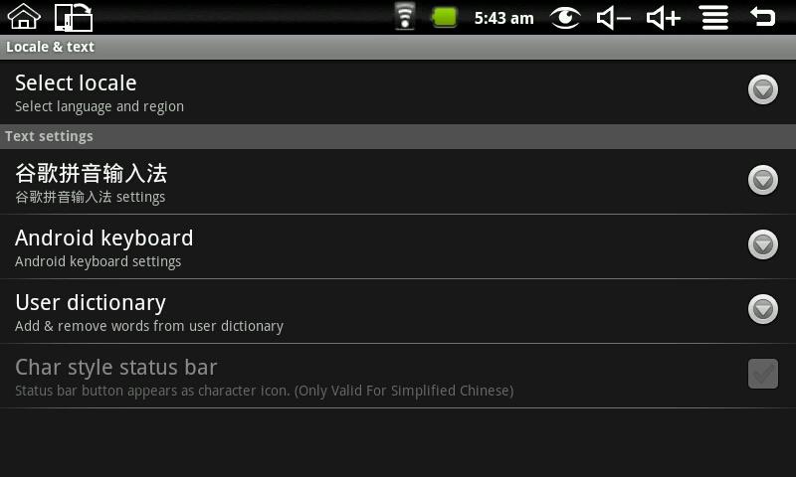
Select local
To select the language and region, press MENU → Settings → Text → choose the language areas and language areas.
Android keyboard
To choose Android keyboard and do Android keyboard settings, press MENU → Settings → Text → Android regional and language keyboard.
Google Pinyin Input Method
To select the Google Pinyin input method, and to set up Google Pinyin input method, press MENU → Settings → Language → regional and Google Pinyin text input method.
User dictionary
To add words to the user dictionary and remove the word from the user dictionary, press the MENU → Settings → Language → user dictionary region and language.

9.7 About device
View legal info, device status and software version
Status
To view the battery status, battery power, WIFI address and boot time, press MENU → Settings →about device → status.
Battery use
To view the power situation, press MENU → Settings →about device → battery use.
Legal information
To view the relevant legal information, press MENU → Settings → about device→ Legal information.
Model number
To view the model, press MENU → Settings → about device→ model number.
Firmware version
To view the firmware version, press MENU → Settings →about device → firmware version.
Kernel version
To see the kernel version, press MENU → Settings → about device→ kernel version.
Build number
To view the build number, press MENU → Settings → about device→ build number.

9.8 Touchpanel calibration
If you want to calibration the touch screen, press MENU → Settings → touchpanel calibration. Follow the prompts touch screen calibration, the calibration is complete there will be prompt and returns the corresponding list of settings.

10. MID locked
Screen / device lock:
1. When screen idle (do not press any buttons), the device will lock the screen automatically in accordance with the system;
2. Short press the power button in any system interface can turn off the screen light and lock the screen.
Screen / device unlock:
1. Press Back or Menu to display unlock screen requirements;
2. If you have a set pattern or password locked, the system will ask you to enter the information.

11. Troubleshooting

11.1 Forced shutdown
Press and Machinery Power key for 5 seconds, device will force the shutdown.

11.2 Restore default settings
To restore the device to factory settings and clear all information, press MENU → Settings → SD cards and equipment storage → restore factory settings.
Warning: Reset the device selected will delete Google accounts, system and application data and settings, downloading applications, please use this carefully.

