D2004
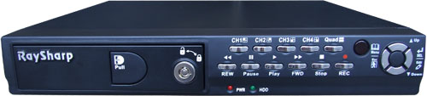
Features:
Mini design for homes, small retail stores, offices
MJPEG compression
High resolution picture quality
Record modes: motion detection / time schedule
Motion detection: area selection & sensitivity adjustment for each camera
PC playback & backup via built-in USB 2.0 port
With auto switch display function
System self-recovery after power reconnected
Password protection
IR remote control included
Specifications:
Model | D2004
Compression | MJPEG (12-20kbytes / frame)
Video I/O | BNC 4-channel inputs / 1-channel output
Display Resolution | NTSC: 720x480 PAL: 720x576
Max. Display Frame | NTSC: 120 frames (4x30 frames)  PAL: 100 frames (4x25 frames)
Max. Record Frame | (Quad Mode) NTSC: 30 frames PAL: 25 frames
Max. Record Frame | (Each Mode) NTSC: 7.5 frames PAL: 6.25 frames
HDD Interface | PATA-100, removable HDD tray, supports to install 250G HDD
Estimated  Recording Time | NTSC: 162 hrs. with 250G HDD @ 30fps@ normal picture quality
Estimated  Recording Time | PAL: 194 hrs. with 250G HDD @ 25fps @ normal picture quality
Record Modes | Schedule, Motion Detection
Record Picture Quality | Low, Normal, High
Display Modes | Each, Quad, Auto-switch
USB Interface | USB2.0
Remote Control | IR remote control
Power Supply | DC 12V / 3A (adapter included)
Dimensions (DxWxH) | 250x235x38mm

