The DVR upgrade process by USB DISK

First:Unzip the upgrade file. 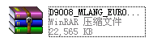

Second:Copy the dvrupgrade file to rootfile of USB disk. 

Third:Connect the USB disk to DVR.
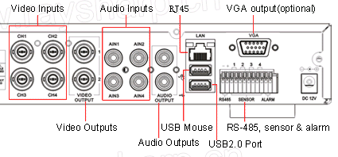

Forth:Click the right button of the mouse,and it will popup a window of MAIN MENU.
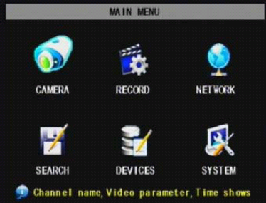
Fifth:Select the SYSTEM icon
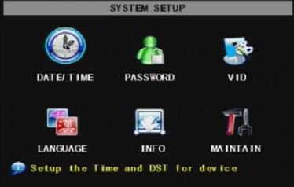

Sixth:Select the MAINTAIN icon
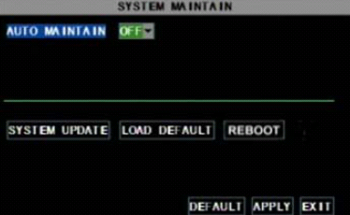

Seventh: Click SYSTEM UPDATE button,the DVR will be prompt to reboot after upgrading successfully.

